There’s something new under the sun dial

While perusing the 1914 Sundial booklet, I came across the information that "on one side of the gnomon is an exact table giving the minutes that must be added to or be deducted from sundial time in order to get true local time [clock time]." That table is long gone, but I thought it would be interesting to make a new table. I obtained the data online from NOAA, the National Oceanic and Atmospheric Administration. The underlying mathematics is complex due to the elliptical orbit of the earth around the sun and the tilt of the earth's axis relative to its orbit.
The resulting table has been placed next to the stairs at the south entrance to the Sundial, and hopefully will someday be replaced with a permanent bronze plaque. Sundials can be accurate to one or two minutes; our Ingleside Terraces Sundial with its 28 foot gnomon is one of the few that can be read that precisely. More info is found on our website https://www.sfog.us/solar/sfsundials.htm

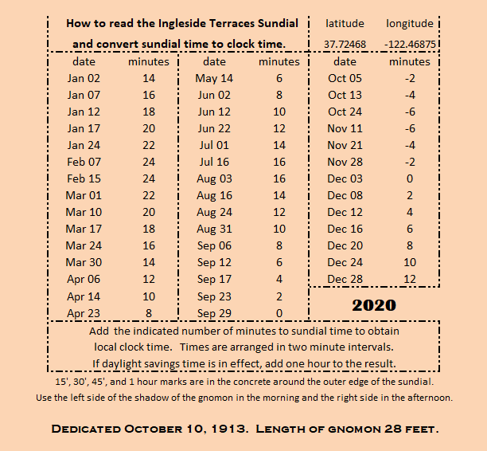

Add the indicated number of minutes to sundial time to obtain local clock time.
Times are arranged in two minute intervals.
If daylight savings time is in effect, add one hour to the result.
15', 30', 45', and 1 hour marks are in the concrete around the outer edge of the sundial.
Use the left side of the shadow of the gnomon in the morning and the right side in the afternoon.

